RDA Microelectronics
Document Name
Revision Number

Author
2015/4/15

Revision History

Revision | Date | Author | Reviewer | Description
0.01

Index
Revision History 2
1 Overview 4
1.1 Chapter 1 Sub 1 4
1.2 Chapter 1 Sub 2 4
1.2.1 Chapter1 Sub 2 -1 4
2 Chapter 2 5

Features

Block Diagram

Chip Block Diagram
Figure 1 RDA5856 Chip Block Diagram

RDA5856 DBB Block Diagram

Figure 2 RDA5856 DBB Block Diagram

RDA5856 Core Block Diagram
Figure 3 RDA5856 Core Block Diagram

Packages and Pinout

Signals

Package Types

TSSOP24
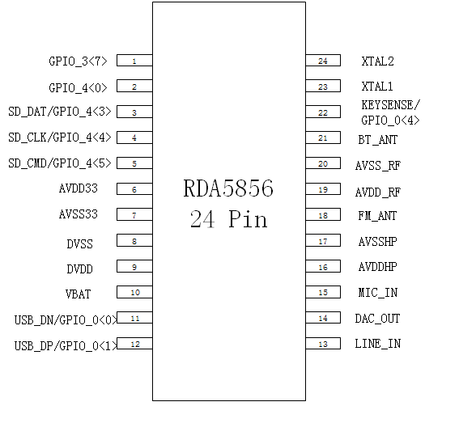

QFP48

QFP48, with external reset
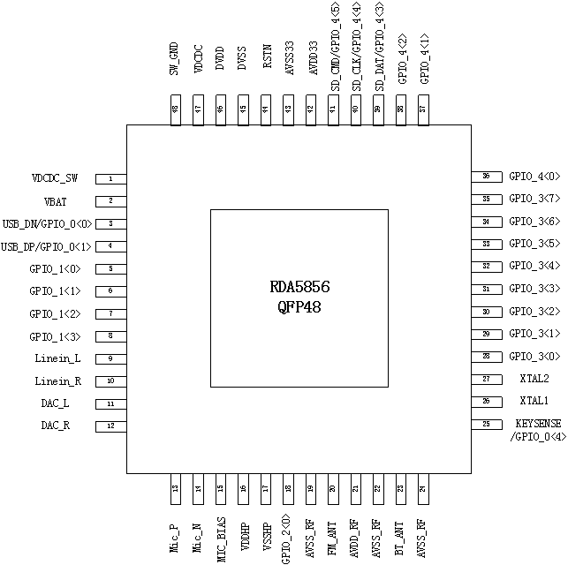

QFP48, without external reset
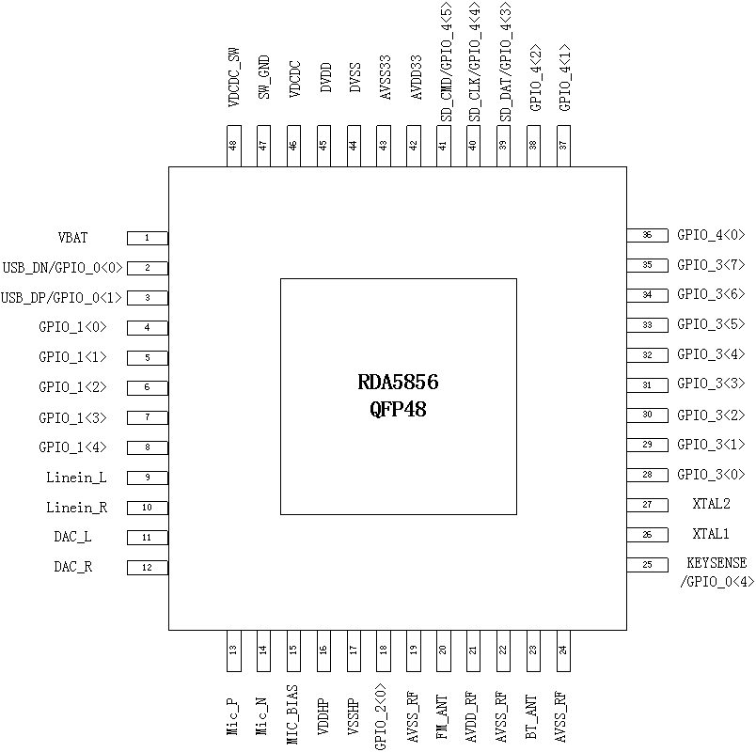

QFN60
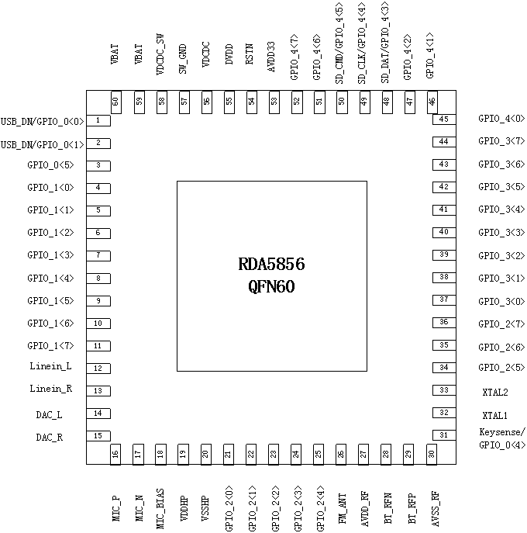

IOMUX

CPU System

Overview
There are two CPU in rda5856. One is XCPU and the other is BTCPU. XCPU is the host, and BTCPU is the BT device. XCPU will boot first

MIPS CPU
Both XCPU and BTCPU are MIPS CPU; they have the same configuration except the ROM base address.
- XCPU ROM Base Address: 0x01E0_0000
- BTCPU ROM Base Address: 0x01E8_0000
D cache and I cache are removed from MIPS CPU in RDA5856, instruction is fetched through MIPS CPU TCM interface. The TCM interface is converted to AHB and connected to bus matrix.
- XCPU TCM Access Address Range
0x01E0_0000 ~ 0x01E0_3FFF
0x0800_0000 ~ 0x0FFF_FFFF
- BTCPU TCM Access Address Range
0x01E8_0000 ~ 0x01E8_FFFF
0x0800_0000 ~ 0x0FFF_FFFF

Memory Map
Figure 4 RDA5856 Memory Space

BT_Modem and BT_RF are mapped to ABP bus when they are accessed through APB SPI. The mapping scheme is as following:
APB Address = 0x0160_8200 + SPI Offset [6:0] * 4
SPI Offset 0x3F is page select address, page 0 is selected if Bit[0] is 0 else page 1 is selected.

Table 1 Modem and RF SPI address Mapping
SPI Modules | SPI  offset | SPI  Offset[6:0] | APB  Address
BT_RF | 0x00~0x3E  0x3F  0x80~0xBF | 0x00~0x3F | 0x0160_8200 ~  0x0160_82FC
BT_Modem | 0x3F  0x40~0x7F  0xC0~0xFF | 0x3F  0x40~ 0x7F | 0x0160_82FC  0x0160_8300 ~  0x0160_83FC

Interrupt

XCPU Interrupt Table
Figure 5 XCPU Interrupt Table

BTCPU Interrupt Table
Figure 6 BTCPU Interrupt Table

Bus Matrix

XCPU Bus Matrix
Figure 7 XCPU Bus Matrix

BTCPU Bus Matrix
Figure 8 BTCPU Bus Matrix

Clock and Reset Control

Clock Control

Instruction
SYS_CTRL register includes several registers which is used to control clock. There is a lock scheme to prevent changing important clock register by mistake.
User should write SYS_CTRL register reg_dbg with 0xA50001 to unlock write, and write with 0xA50000 to lock write again.

Following registers are lock protected.
- FORCE_WAKEUP
- IGNORE_CHARGER
- SYS_RST_SET
- BB_RST_SET
- CLK_SYS_DISABLE
- CLK_SYS_DISABLE2
- CLK_PER_DISABLE
- CLK_BB_DISABLE
- SEL_CLOCK
- FORCE_DIV_UPDATE
- CFG_CLK_BB
- CFG_CLK_OUT
- PLL_CTRL

PLL Clock

624MHz PLL Clock can be selected between AUX-PLL and BB-PLL in ABB, by register PLL_AUX_SDM_CLK_TEST_EN. It comes from AUX-PLL by default.

PLL should be enabled first; it is controlled by SYS_CTRL register PLL_ENABLE or BB_PLL_ENABLE accordingly. XTAL 26M must be enabled first before enable PLL because PLL use XTAL 26M as reference clock. The PLL clock input can be bypassed to 26MHz XTAL clock when SYS_CTRL register PLL_BYPASS is set.

PLL/BB_PLL_ENABLE also can be change by TCU hardware control signals except APB bus. A hardware pulse is generated when TCU RF Clock (That is XTAL 26M clock) is ready if TCU register LPS_PU_MASK_ST_PLL is set to 1 (default is 0), this pulse will change SYS_CTRL register PLL/BB_PLL_ENABLE, PLL/BB_PLL_LOCK_RESET, PLL/BB_PLL_CLK_FAST_ENABLE to 1 if
SYS_CTRL register PLL_DISABLE_LPS is 0.

PLL frequency should be confirmed before use. There is a hardware module “pll_ctrl_lock”, which is in charge of monitor the frequency and indicate the result. “pll_ctrl_lock” use the dived by 2 clock clk_pll_312m to counter the cycle of reference 26MHz XTAL clock. PLL lock is asserted if t count is in the range of 10 to 14 consecutive three times.

The lock information can be check by SYS_CTRL register PLL_LOPCKED. The “pll_ctrl_lock” module also can be reset by SYS_CTRL register PLL_LOCK_RESET.

User should reset “pll_ctrl_lock” module first before enable PLL, prevent the locked information got from last pll_clock.

The internal PLL clock can finally be used by set SYS_CTRL register PLL_CLK_FAST_ENABLE after lock is detected.
Figure 9 System PLL Clock Structure

System Clock
Figure 10 System Clock Structure
Clock_Sys and Clock_Per are the same clock, except they are will be controlled by different clock gating control signals.

System clock has three types of source, XTAL 32K Clock, XTAL 26M Clock and PLL Clock. There is also a CLK52M which doubled from CLK_26M.

System clock uses XTAL 32K clock after power on reset. It switches to XTAL 26M if SYS_CTRL register SLOW_SEL_RF is set to 0. SYS_CTRL register SLOW_SEL_RF can be written by APB bus, and also can be modified by control signals from TCU. A hardware pulse is generated when TCU RF Clock (That is XTAL 26M clock) is ready if TCU register LPS_PU_MASK_SW_RF is set to 1 (default is 1), this pulse will change SYS_CTRL register SLOW_SEL_RF to 0. SYS_CTRL register RF_DETECT_BYPASS control the actual switch time. System clock is switch to 26M clock at once if SLOW_SEL_RF is 0 when RF_DETECT_BYPASS is set, otherwise clock switch after XTAL 26M clock is detected.

RF Edge Detector is just a 3 bit counter, it counts at rising edge of XTAL 26M clock, and will keep at 7. It is reset when XTAL 26M is disabled and it also can be reset by SYS_CTRL register RF_DETECT_RESET.

System clock can switch to PLL after XTAL26M and PLL is ready. The PLL Divider includes a 4 to 1 clock switch; it can select PLL clock, XTAL 52M, XTAL 39M and XTAL 26M. XTAL39M is divider by 1.5 from XLTA. The output frequency is controlled by SYS_CTRL register FREQ, XTAL clock is selected when SYS_CTRL register DIGEN_H is set. It will wait for PLL locked first and then use PLL clock when SYS_CTRL register DIGEN_H is changed from 1 to 0.
Table 2 PLL Divider Summary
FREQ | DIGEN_H | PLL Divider Output
4’b1101 | N/A | 312(624/2) MHz Clock divider from PLL
3’b1100 | N/A | 250(624/2.5) MHz
4’b1011 | N/A | 208(624/3) MHz Clock divider from PLL
4’b1010 | N/A | 178(624/3.5) MHz Clock divider from PLL
4’b1001 | N/A | 156(624/4) MHz Clock divider from PLL
4’b1000 | N/A | 139(624/4.5) MHz Clock divider from PLL
4’b0111 | N/A | 125(624/5) MHz Clock divider from PLL
4’b0110 | N/A | 113(624/5.5) MHz Clock divider from PLL
4’b0101 | N/A | 104(624/6)MHz Clock divider from PLL
4’b0100 | N/A | 89(624/7) MHz Clock divider from PLL
4’b0011 | N/A | 78(624/8)MHz Clock divider from PLL
4’b0010 | 0 | 52(624/12)MHz Clock divider from PLL
 | 1 | 52MHz XTAL clock
4’b0001 | 0 | 39(624/16)MHz Clock divider from PLL
 | 1 | 39MHz Clock divider from 52MHz XTAL Clock
4’b0000  Others | 0 | 26(624/24)MHz Clock divider from PLL
 | 1 | 26MHz XTAL Clock

The PLL Divider clock frequency is not updated immediately; depend on the register setting of TCU. User can write 1 to SYS_CTRL register FOREC_DIV_UPDATE to update force frequency update. The frequency is also updated immediately if SYS_CTRL register TCU_13M_L is 0 and TCU register ENABLE_QBIT is 0.

The clock switch between clk_pll_sys and clk_slow_sys is controlled by SYS_CTRL register SYS_SEL_FAST, Switch to clk_pll_sys may be not immediately depended on the value of SYS_CTRL register DIGEN_H and PLL_BYPASS_LOCK. Switch to clk_pll_sys is done immediately if DIGEN_H is 1 or PLL_BYPASS_LOCK is 1.

NOTE:
SYS_CTRL register PLL_BYPASS must be set if user want disable PLL and use XTAL 26/39/52 M clock as system clock.

VOC Clock
VOC clock structure is similar with system clock except following differences:
- The frequency select register is SYS_CTRL register VOC_FREQ and PLL and clk_slow_sys switch controlled by register VOC_SEL_PLL.
- The default value of VOC_SEL_PLL is 0, clk_pll_voc is selected.
- VOC frequency is take effect immediately after VOC_FREQ is set.
Figure 11 VOC Clock Structure

SPI FLASH Clock
SPIFLASH clock structure is similar with system clock except frequency is controlled by SYS_CTRL register CLK_SPIFLASH_DIVIDER.

AIF TX STB Source Clock
The AIF TX strobe source can be selected from 48MHz clock which is divided from PLL clock, XTAL 26MHz clock and clk_codec from ABB. Clk_codec is selected by default.
Figure 12 AIF TX STB Source Clock Structure

I2S BCLK
BCLK can be derived from external GPIO or divided from clk_codec. Clk_codec is selected when AIF is I2S master and external clock from GPIO when AIF act as I2S slave.
The clock polarity can be changed by AIF register BCK_POL when use AIF as I2S slave.
Clk_codec divider is controlled by SYS_CTRL register AUDIOBCK_DIVIDER, the actually divider ratio is
AUDIOBCK_DIVIDER add 2.
Figure 13 I2S BCLK Clock Structure

Debug Host UART Clock
The debug host UART clock can derive from UART0 clock. UART0 clock source can be selected from clk_slow or clk_156m, by SYS_CTRL register CFG_CLK_UART0. UART_SEL_PLL. UART clock divider is controlled by SYS_CTRL register CFG_CLK_UART0.UART_DIVIDER.

User can input HST_CLK from GPIO; it will be divided first before feed to module “Sequenced Clock Switch”. The divide ratio is controlled by debug host internal register 0x02, the default value is 2 (That is divide by 4 actually).
The module “Sequenced clock switch” is working under XTAL 32K clock, it detect the rising edge of 1/1024 HST_CLK, and assert hst_clk_select after make sure the frequency of HST_CLK is larger than 512K.
Host UART clock is switch to clk_hst_uart_switch after hst_clk_select is asserted.

Figure 14 Debug Host UART Clock Structure

UART1 Clock
UART1 clock source can be selected from clk_slow or clk_156m, by SYS_CTRL register CFG_CLK_UART1. UART_SEL_PLL. UART clock divider is controlled by SYS_CTRL register CFG_CLK_UART1.UART_DIVIDER.
Figure 15 UART1 Clock Structure

Debug Clock
Clk_dbg can divided from clk_156m, the divider ratio is SYS_CTRL register CLK_DBG_DIVIDER + 2 or comes from external GPIO, select by debug port register OEN_DBG_CLK.

Output Clock
Figure 16 Clock Output Structure
The clock select is controlled by SYS_CTRL register CLKOUT_SEL and CLKOUT_DBG.
Table 3 CLKOUT Summary
CLKOUT_SEL | Clk_Out_Sel_Div | Clk_Out_Sel_Osc
2’b00 | 0 | 1
2’b01 | 0 | 0
2’b10 | 1 | 0
2’b11 | 0 | 0

If clk_dbg_out_sel is selected, debug port register ENABLE_DBG must be set to 1. The clock source selection can be configured by debug port register DBG_SEL_SOURCE.
Table 4 Clk_dbg_out_sel summary
DBG_SEL_SOURCE | Selected clock
0 | gCLK_Sys(SYS_NOGATE)
1 | gClk_Sys(SYSD_SCI)
2 | gClk_Per(PERD_SPI1)
3 | gClk_Per(PERD_SPI2)
5 | gClk_Per(SYSD_RF_SPI)
6 | gClk_Per(SYSD_OSC)
7 | gClk_Per(SYSD_PWM)
8 | gClk_Per(SYS_XCPU)
9 | gCLk_Sys(SYSD_DAIS_208K)
10 | gClk_Host_Uart
11 | Clk_Pll_Audio_buf0_0
12 | gCLK_BCK
13 | Clk_Dbg_buf0_0
14 | gClk_Dbg
15 | gCLk_Uart1
16 | gCLk_Uart2
17 | gClk_Rf_Rx
18 | gClk_Rf_Tx
19 | 0
20 | Clk_Voc_buf
21 | Clk_32K_Buf
22 | gClk_UsbPhy
23 | 0
24 | 0
25 | Clk_52M
26 | Clk_OSC_buf0_0
27 | Clk_RF_26M_buf
28 | Clk_Slow
29 | Clk_Pll_Fast
30 | Clk_Pll_Voc
31 | Clk_Sys_156M
32 | 0
33 | gClk_TCU
25 | Clk_52M
63 | Clk_26M_In_buf0_0

Reset Control

HW_RESET
DBB reset input comes from PMU; it is synced to 32K XTAL clock domain first. Reset_osc_stretch_l is de-asserted after 256 32K XTAL cycles when DBB reset input is de-asserted, and then it is synced to not gated PCLK domain to generate HW_RESET.
HW_RESET only can be trigged by PMU; it reset following SYS_CTRL special registers which need keep their value during DBB warm reset.
- SW_BOOT_MODE
- BOOT_MODE
- ALARM_CAUSE
- HOST_DEBUG_RESET
- GLOBAL_SOFT_RESET
- WATCH_DOG_RESET

Figure 17 HW_RESET

Debug Host Ctrl/Reg Reset
Figure 18 Debug Host Ctrl/Reg Reset
Rst_host_ctrl_l and rst_host_reg_l are derived from HW_RESET and synced to CLK_HST_UART. Rst_host_ctrl_l will reset host clock detector and host clock divider modules, and rst_host_reg_l will reset debug host internal registers.

Clock Control Reset and Global Reset
Figure 19 Clock control reset and global reset
There are three warm reset sources that can cause global reset. Debug host can write its internal register Host_Reset to generate debug_reset_l. Write 1 to SYS_CTRL register GLOBAL_SOFT_RESET can generate global_soft_reset_l. Watch dog reset sys_wd_reset_l is generated when watch dog function in TIMER is timeout.

XCPU reset and reset_sys_l
There is a soft reset for each reset of sys clock, which is generated by and logic between global reset and soft reset.
XCPU reset is active high, and the others are active low. XCPU also can be reset by force_xcpu_reset_l which comes from debug host internal register.
Figure 20 XCPU reset and reset_sys

Other reset
The reset for other clock domain is generated by module “resync_reset”. It sync global reset and soft_reset to its clock domain and output them with and gate.
Figure 21 resync_reset for other reset

XCPU System

SPI-FLASH

FLASH Cache Controller

USB OTG Controller

VOC

DMA

SYS_IFC System

SYS_IFC

USB Role Detector

UART

Debug Host

0x0 CTRL_SET
Position | R/W | Default | Filed Name | Description
7 |  |  | Host_Reset | Set 1 to generate host reset
6 |  |  | Force_Xcpu_Reset | Set 1 to force XPCU reset
5 |  |  | Debug_Wakeup | Set 1 to generate wakeup
4 |  |  | FBP_XCPU | Set 1 to request stall XCPU
3 |  |  | FBP_BCPU
2 |  |  | IT_XCPU | Set 1 to generate interrupt to XCPU
1 |  |  | IT_BCPU
0 |  |  | Debug_Port_Lock

0x1 CTRL_CLR
Position | R/W | Default | Filed Name | Description
7 |  |  | Host_Reset | Set 1 to clear host reset
6 |  |  | Force_Xcpu_Reset | Set 1 to clear XPCU reset
5 |  |  | Debug_Wakeup | Set 1 to clear wakeup
4 |  |  | FBP_XCPU | Set 1 to
3 |  |  | FBP_BCPU
2 |  |  | IT_XCPU
1 |  |  | IT_BCPU
0 |  |  | Debug_Port_Lock

0x2 CLKDIV
Position | R/W | Default | Filed Name | Description
[5:0] |  |  | Cfg_Clk_Host

0x3 CFG
Position | R/W | Default | Filed Name | Description
7 |  |  | Force_Prio
2 |  |  | Debug_Host_Sel
1 |  |  | Disable_IFC_H
0 |  |  | Disable_Uart_H

0x4 CRC
Position | R/W | Default | Filed Name | Description
1 |  |  | CRC_status | CRC Status
0 |  |  | FC_FiFO_Ovf | IFC FIFO overflow

0x05 H2P_STATUS
Position | R/W | Default | Filed Name | Description
7:0 | r/w |  | H2P_status | Debug Host to APB status

0x06 P2H_STATUS
Position | R/W | Default | Filed Name | Description
7:0 | rw |  | P2H_status | APB to Debug Host Status  Write 0x1 to clear P2H_status

I2C1/2

SPI2/3

Calendar

IR

TIMER

IRQ

Calendar

PWM

GPIO

TCU

CFG_REGS

AHBC Monitor

Page Spy

BB_IFC System

BB_IFC

AIF

BOOT_ROM

BTCPU System

Audio Codec

RTC

Interface Access
RDA5856 includes several analog interface, which can be accessed through external/external I2C or SPI.
The access interface types are list as below table.
Table 5 Interface Access Scheme Summary
Modules | External I2C | Internal I2C | Internal SPI
FM | Ext I2C | I2C2
PMU | Ext I2C | I2C2 | SPI3-CS0
ABB |  |  | SPI3-CS1
Audio Codec |  |  | SPI3-CS1
USB_PHY |  |  | SPI3-CS2
BT_RF | Ext I2C | I2C2 | APB SPI, TAB SPI

Table 6 I2C Device Address and Protocol Summary
Module | I2C Device  Address | Protocol | Comment
FM | 7’h11 | Sequential Read  Sequential Write
PMU | 7’h5F | Sequential Read  Sequential Write
BT_RF | 7’h76  7’h16 (default) | Sequential Read  Current Read  Sequential Write | Configured by register_b2[2:0]  7’h76:register_b2[2:0] = 3’b000 |  3’b100 or 3’b101  7’h16: register_b2[2:0] = others  (default)

I2C Access
The I2C Slave supports sequential read and write. The register address width is 8 and data width is 16 bit.
The register address will increase automatically till I2C STOP detected.

For I2C read, there should be a repeat start and Device Address following register address, the read and write timing are depicted as following:

Figure 22 I2C Sequential Read Protocol
Figure 23 I2C Current Read Protocol
I2C Current Read is read data from a known address, which may be set by previous I2C Sequential Read or Write.
Figure 24 I2C Sequential Write Protocol

SPI Access
There are two types SPI Register Access Interface, one is 7 bit address, which is used in BT_RF, the other is 9 bit address, which is used in USB_PHY, PMU, Audio Codec and ABB.

Another difference between these two types SPI is the access timing:
- 7 Bit Address SPI
Output data is lunched at falling edge and sampled at rising edge.
- 9 Bit Address SPI
Output data is lunched at rising edge and sampled at rising edge.
Table 7 SPI Type Summary
SPI Module | SPI Type
SPI3 | 9 bit address SPI
APB SPI | 7 bit address SPI
TAB SPI | 7 bit address SPI

7 Bit Address SPI
The first bit read/write indicator, 1 means read and 0 means write. Following seven bit the address,
MSB is transmitted first. The output bit is lunched at falling edge of SCLK and input bit is sampled at rising edge of SCLK.
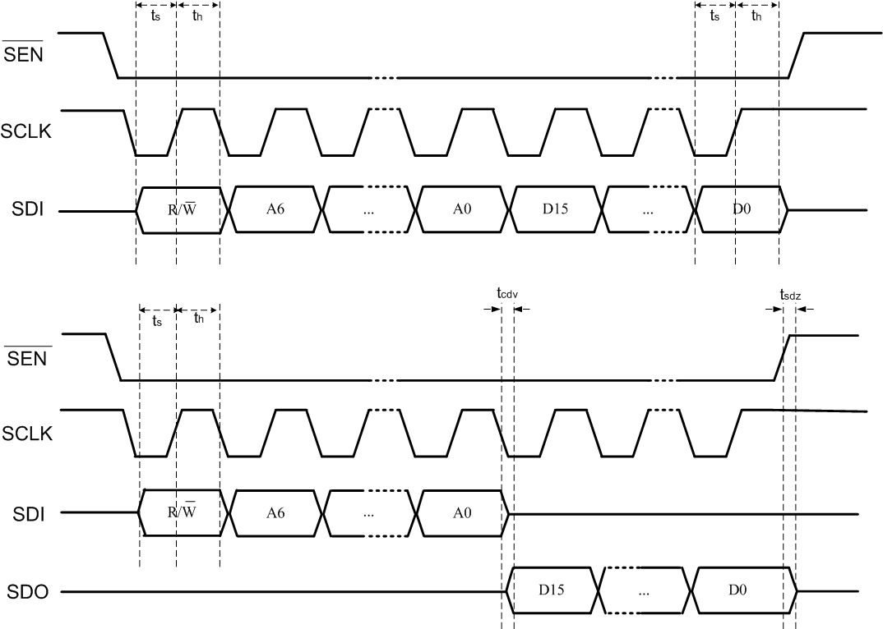
Figure 25 7 Bit Address SPI Write/Read Access Timing
Refer to Table 1 for memory mapping details.

9 Bit Address SPI
The first bit read/write indicator, 1 means read and 0 means write. Following nine bit the address,
MSB is transmitted first.
Slave:
The output bit is lunched at rising edge of SCLK and input bit is sampled at rising edge of SCLK.
Master:
The output bit is lunched at rising edge of SCLK and input bit is sampled at falling edge of SCLK.

Figure 26 9 Bit Address SPI Write Timing

Figure 27 9 Bit Address SPI Read Timing

BT_RF

PMU

ABB

FM

USB_PHY

IO

DFT

Appendix

RDA5856 Register Map

